# 1. Software Requirements Introduction

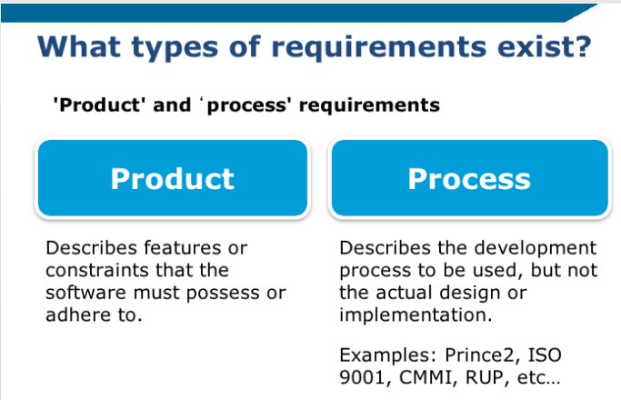

* Dev requirements (clearance), certain program methodologies (agile, scrum, etc)

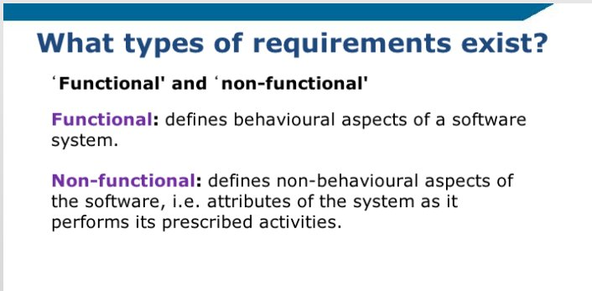

* Functional = directly matched to design requirements (represented in code)
* Non-Functional = desired level of efficiency, performance, maintainability

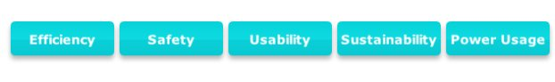

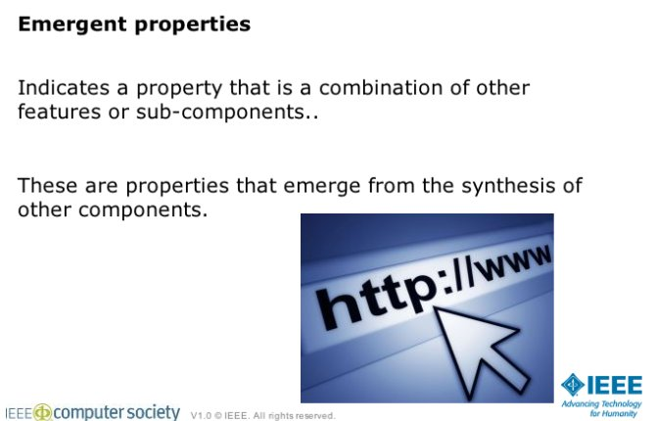

* If product relies on website what is the response time of that site? Chain of requirements that contribute to overall goal (Emergent Property)

